National University of Computer and Emerging Sciences, Lahore Campus

 | Course: | Web Engineering Lab | Course Code:
 | Program: | BS(Computer Science) | Semester: | Spring 2024
 | Duration: | 2 hours | Total Marks: | 25
 | Date | 18-03-2024 | Weight | 5
 | Section: |  | Pages: | 02
 | Name: |  | Roll No.:

Exam instructions: READ ALL INSTRUCTIONS CAREFULLY.

- Understanding the question is also part of the quiz, so do not ask for any clarification. Make suitable ASSUMPTIONS in case of any issues.
- Final Submissions should be done on xeon as well as on Google classroom on your respective section folder on:

\\Xeon/Spring 2024/Marwa Khan/Web Engineering Lab/Quiz/Submissions
Question must be saved with your roll no e.g: “”20L-4444”. Multiple submissions are not allowed (if done, only the first one will be considered). In case of missing or corrupt file submission, all the responsibility will be on the student himself.
- Submission will have two files “20L-4444_Q1” and “20L-4444_Q2”, with the screen shot of both desktop screen and mobile screen in case of responsive else only desktop screen.
- Your cell phones/smart watches MUST be turned off and placed far away from the PCs.
- It is your responsibility to protect your code and save it from being copied. If you don’t protect it, all matching codes will be considered copy/cheating cases. No leniency on plagiarism.
- This is an open book paper and internet is allowed in this exam. You are required to make sure you delete everything from the Desktop of your windows. Also delete all the files permanently from Recycle Bin and Trash respectively for Windows, no student should be found using gmail or any other means of code sharing.
- Submission should also have screen shot of the output.
- Your Mid exam will be immediately cancelled if:
  - You are seen talking, whispering, borrowing or looking at someone’s PC.
  - A USB is found attached to your PC.
  - You are seen using a cell phone/smart watch.

Question:
Write a code to achieve the following template, you have to follow the following restrictions:
- Use div
- Use internal css
- The page should be responsive

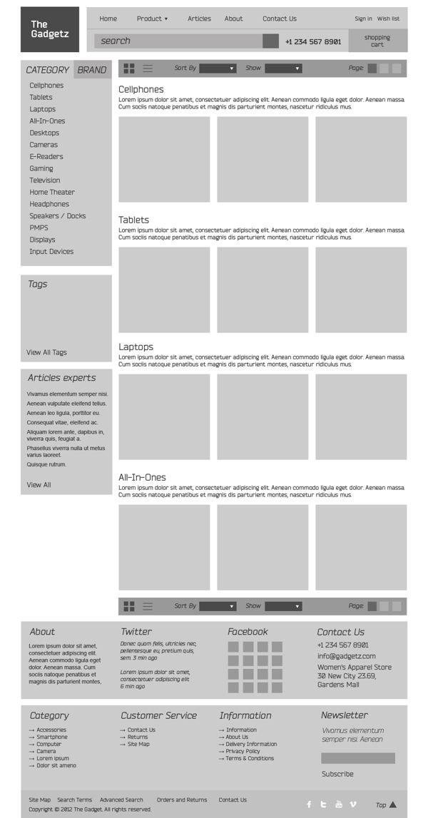

Rubric:
- HTML🡪10 Marks
- CSS🡪20 Marks
- Responsive 🡪10 Marks
- Page accuracy according to given template🡪10 Marks

Question:
Write a code to achieve the following template, you have to follow the following restrictions:
- Make a form
- Use internal css
- Use javescript:
  - The quantity can be from 1 to 5 if not error message should be displayed.
  - Unit cost will remain same.
  - Quantity is required field so proper checks should be placed
  - The total field will have sum of all three costs, after that GST will be calculated.
  - Grand total is a sum of Total and GST.
  - Proper checks should be placed for required field.
  - All the things should be verified when Update Grand Total button is clicked.
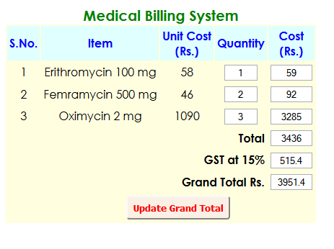
Desktop
Rubric:
- HTML and CSS🡪5 Marks
- JavaScript
  - Empty checks🡪15 Marks
  - Range conditions🡪15 Marks
  - Total🡪5 Marks
  - GST🡪5 Marks
  - Grand Total🡪5 Marks

Best of Luck ☺

